**Module 4- Physical property measurement**

**Experiment 4.1: Thermal Analysis of Pb-Sn Alloy**

**Aim**: To produce thermal cooling curve and report eutectic temperature.

**Theory**:

**Phase Diagrams**

Phase diagrams, sometimes called equilibrium diagrams, are graphs that indicate, for a particular alloy system, the phases that are present at any temperature, with various compositions. The coordinate system of phase diagrams uses temperature as the ordinate scale and weight percentage of the alloy components as the abscissas. The particular temperatures at which phase changes occur are plotted on this diagram for a given alloy composition, and when sufficient experimental points have been determined, lines representing the locii of all phase changes are drawn. These lines are also the boundaries of various phase fields. With the complete phase diagram, the phase or phases existing at any temperature or the phase changes occurring on changing temperature can be easily determined for any alloy of the two elements. The phase diagram is also valuable for determining the percentage amount of a particular phase in a two-phase structure, and it assists in understanding phenomena that occur during rapid heating and cooling. (Fig 9-1) Since most metallurgical operations are completed well below the boiling temperature of the various components of the alloys and at normal atmospheric pressure, vapor phases and the effect of pressure are ordinarily not considered.

**Constructing Phase Diagrams**

Data for constructing phase diagrams may be obtained by several methods. Thermal analysis, microscopical studies, and X-ray diffraction are common. Thermal analysis is the simplest and most used technique. By slowly heating or slowly cooling alloys of known composition while accurately measuring the temperature of the alloy at particular time intervals, plots are obtained which show the variation of temperature with time. Any departure from a smooth curve is an indication of a phase change at the inflection temperature. During the freezing of a pure metal, the latent heat of solidification which is liberated is exactly sufficient to maintain the alloy at constant temperature until freezing is complete. A constant-temperature dwell appears in the cooling t curve. Latent heat liberated during the freezing of a solid-solution alloy is not sufficient to maintain constant temperature, but does decrease the rate of cooling, as seen in Fig. 9-3.

By obtaining cooling curves for several particular compositions of the alloy system being investigated and plotting the inflection temperatures of each cooling curve against the alloy composition, points which indicate regions of phase changes are obtained. Lines representing the loci of phase changes are then drawn, and the lines become the boundaries of phase fields. Fig. 9-2

The thermal-equilibrium diagram is in reality a chart which shows the relationship between the composition, temperature and structure of any alloy in a series. Let us consider briefly how these diagrams are constructed.

A pure metal will complete its solidification without change of temperature whilst an alloy will solidify over a range of temperature which will depend upon the composition of the alloy. Consider, for example, a number of alloys of different composition containing the two metals A and B which form a series of solid solutions (Fig. 9.2). For successive compositions containing diminishing amounts of the metal A, freezing commences at a1 a2, a3, etc., and ends at b1, b2, b3, etc. Thus, if we join all points’ a1 a2, a3, etc., we shall obtain a line called the liquidus, indicating the temperature at which any given alloy in the series will commence to solidify.

Similarly, if we join the points b1, b2, b3, etc., we have a line, called the solidus, showing the temperature at which any alloy in the series will become completely solid. Hence the liquidus can be defined as the line above which all indicated alloy compositions represent completely homogeneous liquids, whilst the solidus can be defined as the line below which all represented alloy compositions of A and B are completely solid. For temperatures and compositions corresponding to the co-ordinates of points between the two lines both liquid solutions and solid solutions can co-exist in equilibrium.

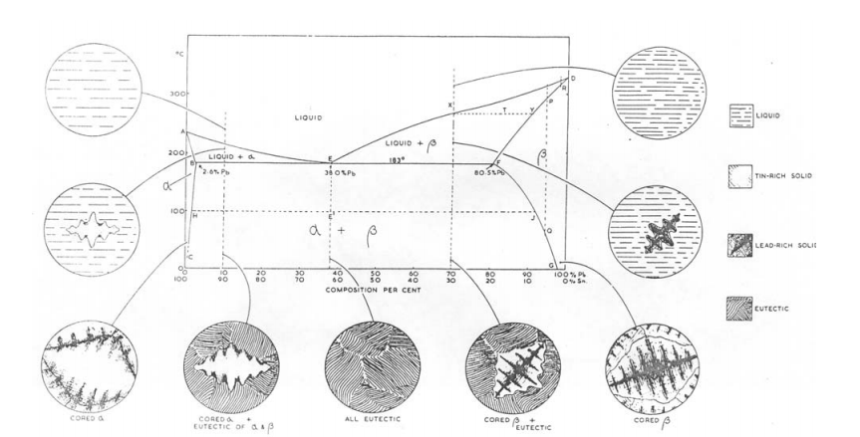

**Fig 9-1 The tin-lead equilibrium diagram. The microstructures indicated are those obtained under non-equilibrium conditions of solidification.**

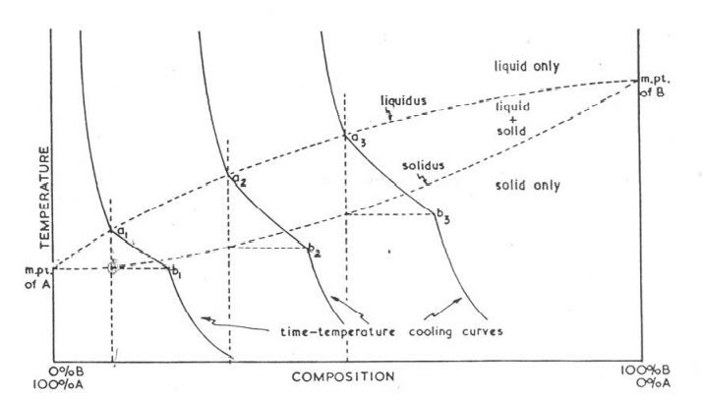

**Fig 9-2 The construction of a simple equilibrium diagram of the solid solution type using cooling curves of a series of alloys.**

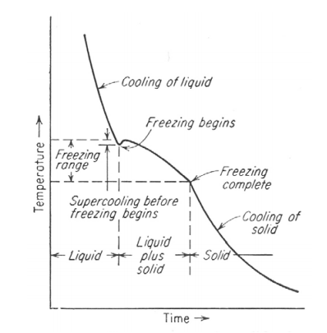

**Fig 9-3 Cooling curve of a solid-solution alloy. Discontinuous changes in slope of cooling curve indicate phase change.**

Pure metals cool relatively uniformly to their freezing temperature and then remain at the freezing temperature until solidification is complete. If doubt exists that a particular sample is pure metal, chemical analysis or X-ray diffraction technique may be utilized to provide indisputable evidence.

Solid solution alloys are microscopically indistinguishable from pure metal but melt over a temperature range rather at constant temperature. X-ray diffraction measurements also indicate the presence of a solid solution through a change of their lattice parameter compared to the pure components. These and other indications prove the presence of solid solution alloy.

**Equipment:**

Fire clay crucibles, Chromel –Alumel thermocouple, furnace with varic, potentiometer for reading thermocouple, Pb-Sn sample.

**Procedure:**

1. The molten alloy is kept in crucible in the centre of the furnace.

2. Immerse Chromel-Alumel thermocouple with protective sheath into the molten metal.

3. The current through the furnace is to be adjusted so that we will get 1 or 2 °c per min.

4. Temperature readings for every1 min has to be recorded using potentiometer. Be sure that you make any necessary reference junction corrections.

**Observations:**

|  |  |  |
| --- | --- | --- |
| **Time**  **Min** | **EMF**  **mV** | **Temperature**  **°c** |
|  |  |  |

**Questions:**

1. Estimate the composition of your sample.

2. Compare the direct and inverse cooling curves

3. Discuss the arrest point in Pb-61.9 % Sn Alloy.

4. What type of binary system is represented by Pb-Sn alloy?

# **Experiment 4.2: Thermal Expansion of Solid Materials**

**Aim:** To study the thermal expansion behaviour of solid materials using a dialgauge dilatometer.

**Theory:**

Almost all materials expand on heating. This can be understood in terms of the potential energy curve. Consider a pair of atoms, bound together in the solid. The potential energy, V(r), of these two atoms varies with their separation, r, and can be represented by:

**V(r) = - a/rm + b/ rn (11.1)**

where a, b, m, and n are constants, and are positive quantities. The first term on the right arises from the attraction between the two atoms (decreasing r lowers the energy); the second term comes from repulsion. These two terms are shown as dotted lines in Fig. 11.1 and the total potential energy by a solid line. The asymmetric shape of the potential energy curve may be noticed. The degree of asymmetry is a function

of the values of the exponent‘s m and n in equation. (11.1) m is always less than n. In ionic crystals, m ~1 and n ~ 12. In molecular crystals, m ~ 6. Note that m = 1 corresponds to coulomb attraction between two point charges. At temperature T1, corresponding to energy E1, the interatomic distance oscillates from r11 to r111 with a mean separation of r1 = (r11 + r111 )/ 2. At a temperature T2 > T1 , the energy is E2 and the average interatomic separation is r oscillating between r21 and r211 . Note that r2 >r1 leading to thermal expansion. Thus, the asymmetric shape of the potential energy curve, which results in anharmonic nature of the lattice vibrations, is responsible for the thermal expansion) A large binding energy leads to a high melting point of a material, i.e., a deep potential energy minimum; in this case, at not too high temperatures, the potential energy curve would be asymmetric only to a small extent. Therefore, a material with a high melting point (Tm ° K) would, near room temperature exhibit a low thermal expansion coefficient ( ). The product ( Tm) , is often empirically found to be constant for a series of related materials.

Isotropic materials can be described by a single potential energy curve and therefore exhibit the same thermal expansion in all directions i.e. have a single value of However, non isotropic crystals have potential energy Vs r curves of different shapes in different directions; consequently they possess different values in various directions. A poly crystalline specimen of randomly oriented non isotropic crystals exhibits an expansion behavior which is an average of that in the various directions. Similarly a multiphase material has thermal expansion behavior which is a weighted average of the expansion coefficients of its component phases. Differential dilatation in different directions in non isotropic materials or in different grains in a multiphase material, may lead to micro cracks and poor mechanical strength.

Determination of the thermal expansion coefficient requires the measurement of two physical quantities, displacement and temperature, for a sample of the material that is undergoing an appropriate thermal cycle.

A diverse range of techniques can be employed for this purpose, and the main ones are outlined below. i) Dial gauge (mechanical magnification) (ii) Optical lever (tilting mirror moves a light beam) (iii) Electrical transducer (capacitive or inductive) (iv) Resistance strain gauge (v) Optical interferometer. Of these the dilatometer with the dial gauge is the simplest and the most common method.

Mechanical Dilatometry is one of the most popular techniques for thermal expansion measurement. A specimen is heated in a furnace and the displacement of the ends mechanically transmitted to a displacement sensor by means of push rods. These can be made from low expansion fused silica for operation to 700°C. Aluminacan extend the technique to 1600°C, and more extreme temperatures require the useof graphite. By compensating for the expansion of the push rods, accuracies of around

1-2 % for the CTE can be obtained.

**Equipment:**

A fused-silica tube, dial-gauge dilatometer, Furnace, Power supply, Temperature controller, Potentiometer, Thermocouple (chromel-alumel). Specimens (Pyrex. sodalime-silica glass. aluminum. mild steel. building brick. fireclay brick. etc.

**Procedure:**

1. Mount one of the samples (A) at the bottom of the fused-silica tube (B) which is closed at one end. A fused-silica tube (C), closed at both ends, is placed on top of the specimen. A dial gauge (D), with a least count of 0.001 mm, is attached to the top of the outer silica tube by an inconel clamp (E). The completed assembly is shown in Fig. 11.2

2. The whole assembly is inserted in a tube furnace, the temperature of which is controlled with a chromel-alumel thermocouple.

3. The apparatus is equilibrated at different temperatures. The dial gauge reading and the temperature of the specimen determined with a thermocouple (chromel-alumel) located at F (Fig11.2) and a potentiometer.

**Observations:**

1. Note the initial dimensions of the sample and the dial gauge reading.

2. Plot. ( L/ Lo) Vs Temperature.

3. Calculate the average linear thermal expansion coefficient from the plot. = (1/L ) .( L/ T)

**Questions**

1. How do you correct the value of ?

2. What is the volume expansion coefficient of your sample?

3. Why are fused silica and inconel used for dilatometer construction?

4. Why do we use a fused-silica tube closed at both ends instead of a fused silica rod?

5. Can you use the same dilatometer for measurements below room temperature?

6. What is the magnification of the dial gauge that you used? How can you increase

it?